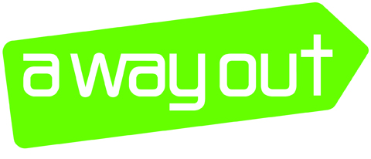

Trustee Application Form

Please complete this form CLEARLY in black ink, or type.

Personal details
Surname
First name/s
Date of birth
Home address
Telephone
Mobile
Email

Education
Please outline your Education and Professional Qualifications

Other Training

Employment, responsibilities and activities
Details of previous employment, responsibilities including roles within other management committees, church leadership teams, charities etc. Please include any previous experience of work that you feel would be relevant to your role as a trustee of A WAY OUT.

Criminal record
I agree to undertake a DBS check prior to acceptance as an A Way Out Trustee.
Yes / No

Personal character summary
Please write a paragraph about yourself – your personal/practical skills, faith, beliefs, character, strengths and weaknesses, etc.

Background Details
Why do you want to become a Trustee of A WAY OUT?

Skills
Please tick in which area you feel you could make the most difference to the organisation (please give either a 1, 2 or 3 in order of preference)

Child Protection Finance Human Resources Young People

Marketing/Comms Fundraising Commissioning Quality

Workforce Development Management Health/Social Care Monitoring & Evaluation

Policies & Procedures Legal Women’s Services Strategic planning

Change Management/ Addictions IT Systems
Organsational Restructure

What specific support do you feel you could offer A WAY OUT?

Referees
Please give details of two referees, neither of whom should be relations
1. | Role / Position
 | Name
 | Address
 | Tel/email

2. | Role / Position
 | Name
 | Address
 | Tel/email

Declaration
I confirm that, to the best of my knowledge, the information in this form is accurate:
Signed: | Date:
If applicant is under 18, a parent/guardian must sign in support:
Signed: | Date:

